**Apache, Nginx, Tomcat**

**Apache: -**

#Enable apache working as a proxy [by default it not works]

Cd /etc/apache2/mods-available

A2enmod prory #Proxy enable

A2enmod prory_http #Prory_http enables

Service apache2 restart

#Configure request re-routing from apache2 to tomcat.

Vi /etc/apache2/sites-enable/000-default.conf

# servername [www.example.com](http://www.example.com)

ProxyPass /docs <http://Tomcat-IP:8080/docs/>

ProxyPassReverse /docs <http://Tomcat-IP:8080/docs/>

Service apache2 restart

**TOMCAT:-**

webapps /usr/local/tomcat/webapps #War file location

Server.xml /usr/local/tomcat/conf/server.xml #PORT change, SSL Certificate configuration

User.xml /usr/local/tomcat/conf/user.xml # tomcat login details

Contex.xml /usr/local/tomcat/conf/contex.xml # add DB Credentials

Startup.sh root@4e72bcc35f53:/usr/local/tomcat/bin# ./startup.sh start # Start Tomcat

**SSL CERTIFICATE CONFIGURATION IN TOMCAT: -**

Vi server.xml

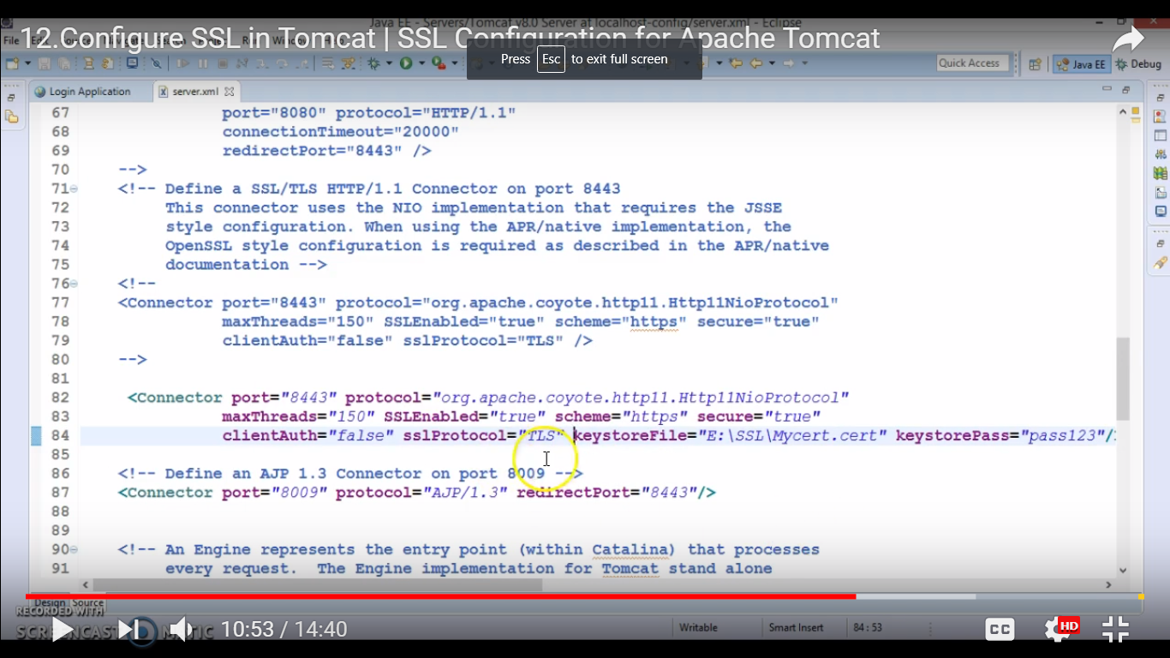

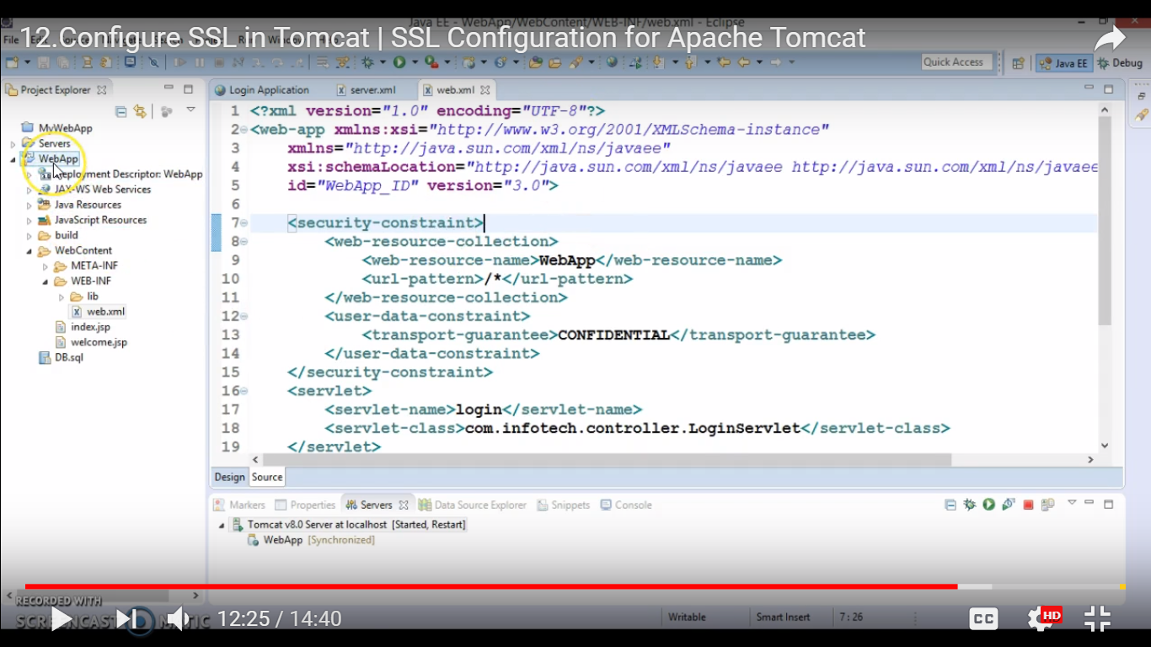

**SSL CERTIFICATE CONFIGURATION IN NGINX: -**

Vi /etc/nginx/site-available/testapp

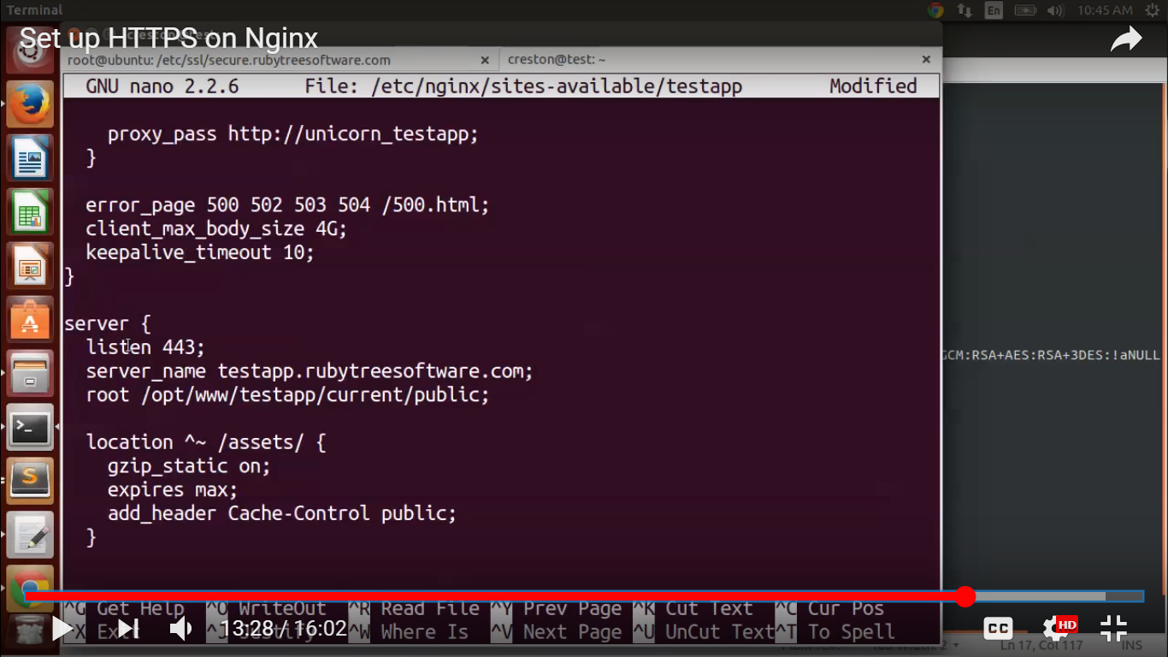

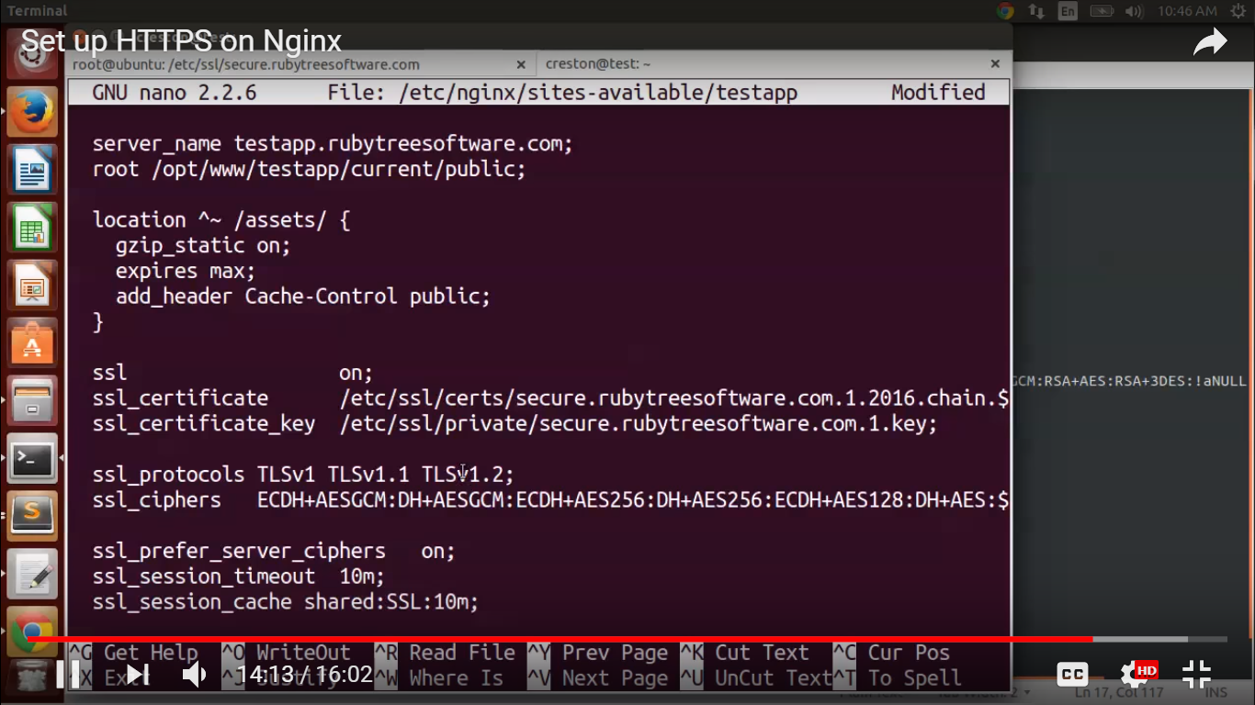

tc/hostname

192.168.2.1

Change

Node-1

#Specify Node Names

vi /etc/hosts

192.168.2.5

Change

192.168.2.10 Master

192.168.2.5 Node-1

192.168.2.5 Node-2

#Host Name expose Environment variable

export NODE-1_IP=”NODE PUBLIC IP”